Install LPCXpresso 7.6.2 by going here:

<http://www.lpcware.com/lpcxpresso/downloads/windows>

(The newer versions of LPCXpresso have a regression, so for now, use version 7.6.2.)

I’ve only tried the Windows version, so I’d recommend going with Windows first, then if you want to try the other versions, give them a try, and please tell us how it goes.

Clone the source and switch to the gcc branch:

git clone https://github.com/charmedlabs/pixy.git gcc

cd gcc

git checkout gcc

Fire up LPCXpresso.

Point your workspace to the ~/src/device directory by selecting File->Switch Workspace:

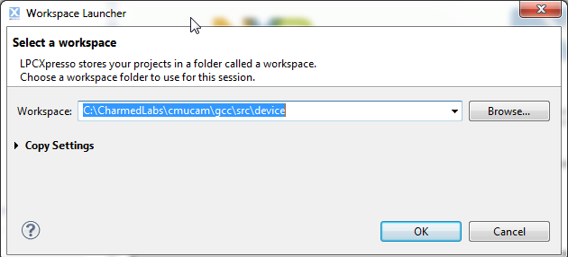

Now select File->Import. In the Import dialog, choose “Existing Projects into Workspace”:

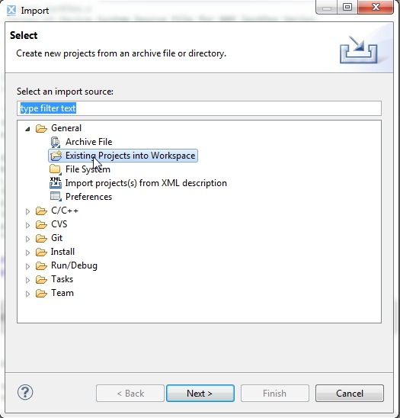

Click on the Browse button and browse to the ~/src/device directory. It should bring up all of the projects (see below). Click on Finish.

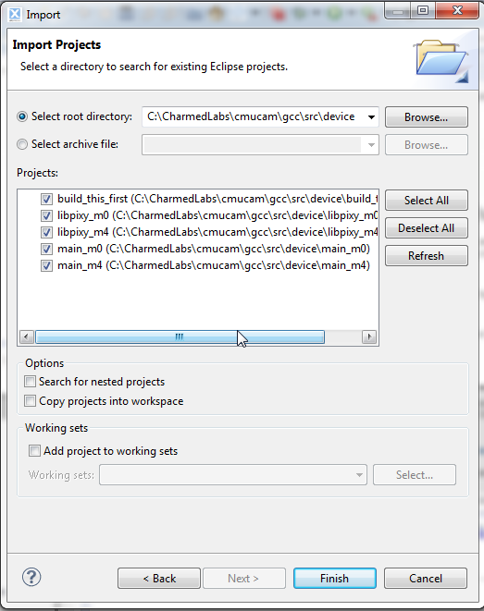

Click on build_this_first in the Project Explorer tab:

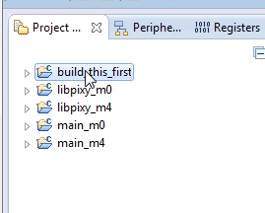

Click on “Build ‘build_this_first’” in the Quickstart Panel:

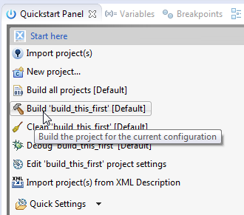

Do the same for all of the other projects in the Project Explorer tab, in order:

1. Click on “libpixy_m0”, then “Build ‘libpixy_m0’”, wait for it to build
2. Click on “libpixy_m4”, then “Build ‘libpixy_m4’”, wait for it to build
3. Click on “main_m0”, then “main_m0’”, wait for it to build
4. Click on “main_m4”, then “Build ‘main_m4’”, wait for it to build

When you are done, you should have the firmware file “pixy_firmware.hex” in the ~/src/device/main_m4/SPIFI directory. You can then upload into Pixy using PixyMon.

If you want to build from the command-line. I recommend installing Cygwin (it will probably work in mingw as well…) Or if you’re in MacOS or Linux, you’re set.

You will need to add arm-gcc to your path, so add this line to your .bashrc file (note the version dependency):

export PATH=$PATH:/cygdrive/c/nxp/LPCXpresso_7.3.0_186/lpcxpresso/tools/bin

Cd into the firmware directory:

cd src/device

Then type make. The default target is the spifi (flash) file. It will be ~/src/device/main_m4/SPIFI/pixy_firmware.hex once it’s finished building.